**Lunar Cycle Craze?**

Team Members:

Fox Aufenger, Chris Barlow, Anne Ramer, Bridget Reardon

* **Core Message and Hypothesis**
  + Does a full moon impact crime rate?
    - In this project, we analyze 2016 crime rates in three major US cities - Baltimore, Boston and Philadelphia as they relate to a full moon. We consider various types of crime while observing the cycles of the moon attempting to find a correlation between the lunar cycle and crime rate.
    - Alternate Hypothesis: On days where full moons occur, the crime rates are greater.
    - Null Hypothesis: On days where full moons occur, crime rates are equal.
* **Questions Considered** 
  + Does the lunar cycle affect crime in Baltimore, Boston and Philadelphia?
    - We selected these three cities as they are all major cities on the east coast.
  + Is crime higher during a full moon?
    - We thought this would be supported by a full moon as it provides more moonlight.
  + Are the trends consistent across all three cities?
    - We wanted to see if a full moon had similar implications in the three cities.
* **Data Summary**
  + Full Moon Calendar
    - The Full Moon Calendar depicts the day of full moons from 1900-2050.
    - <https://www.kaggle.com/lsind18/full-moon-calendar-1900-2050>
  + Crime in Baltimore
    - The Crime in Baltimore dataset contains crime incident reports provided by the Baltimore Police Department.
    - <https://www.kaggle.com/sohier/crime-in-baltimore>
  + Crimes in Boston
    - The Crimes in Boston dataset includes incident reports provided by the Boston Police Department and contains the times, locations, and descriptions of crimes.
    - <https://www.kaggle.com/AnalyzeBoston/crimes-in-boston>
  + Philadelphia Crime Data
    - The Philadelphia Crime Data contains incident reports of the Philadelphia Police Department provided by OpenDataPhilly.
    - <https://www.kaggle.com/mchirico/philadelphiacrimedata>
  + Potential issues with our data include:
    - Crimes that were never reported
    - Crimes reported that did not actually happen
    - Incidences that were not considered as crimes after court rulings
    - The effect of holidays on crimes
* **Data Exploration and Cleanup Process**
  + Data imports from public data frames
  + Data cleanup for each city
    - Narrow data frames to focus on crimes in 2016
    - Store data chronologically into Pandas data frame
    - Create data frame to find the full moons in each month of the year
    - Sort full moon data by month
* **Analysis Process** 
  + For the year 2016, we analyzed each month individually to find the below information:
    - The day the full moon took place in that month
    - Total number of crimes reported
    - Average number of crimes per day
    - The day with the highest crime rate
    - The day with the lowest crime rate
    - Total crime committed on the day with the full moon
    - Percentage of monthly crime committed on the day with a full moon
    - The rank of the crime committed on the day with the full moon in relation to the crime committed on the rest of the month
  + Statistical analysis of data found
  + Creation of data visualizations
    - Bar graph
      * Depicts the crime per day per month
      * The redline on the graph highlights the crime total for the day with a full moon.
* Multi-Bar Graph
  + Compares the maximum crime, minimum crime and day of full moon for each month
* Pie Chart
  + Shows total crime committed on days with a full moon compared to crime committed on every other day in 2016
* **Conclusions**
  + For all three cities, the annual crime committed on nights with a full moon (12 days) was 3.3%.
  + For all three cities, the average crime committed per 12 days was 3.3%.
  + 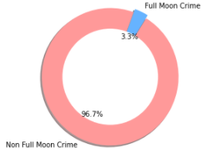
  + Boston:
    - The graph shows the maximum crime, minimum crime and full moon crime data onto a multi-bar graph.

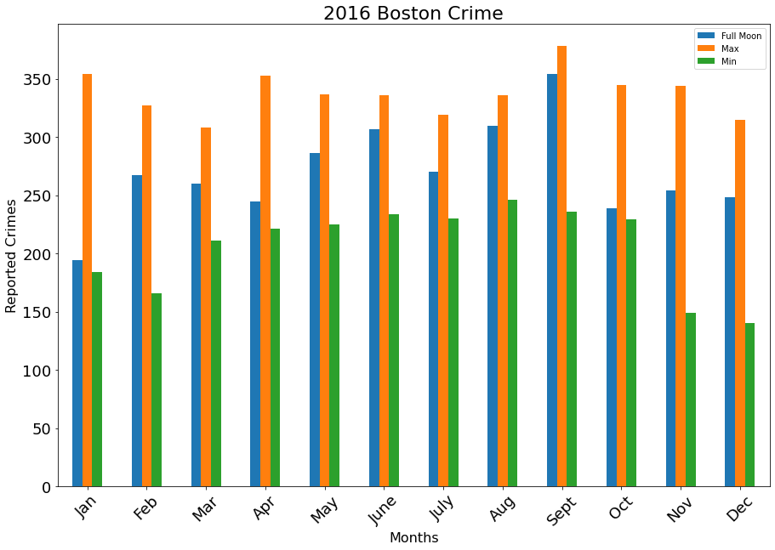

* + Month with day of most crime:

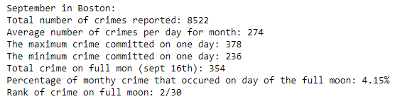

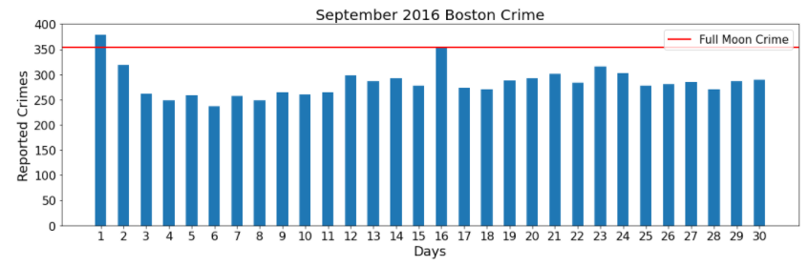

* Month with day of least crime:

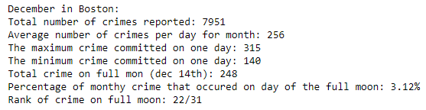

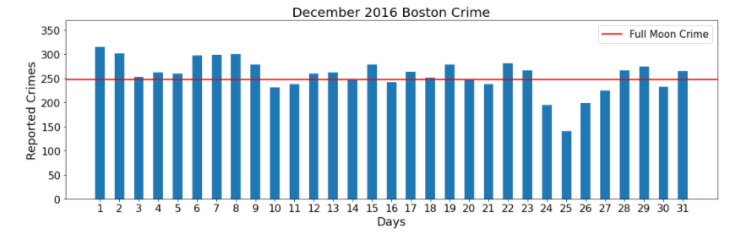

* + Baltimore:
    - The graph shows the maximum crime, minimum crime and full moon crime data onto a multi-bar graph.

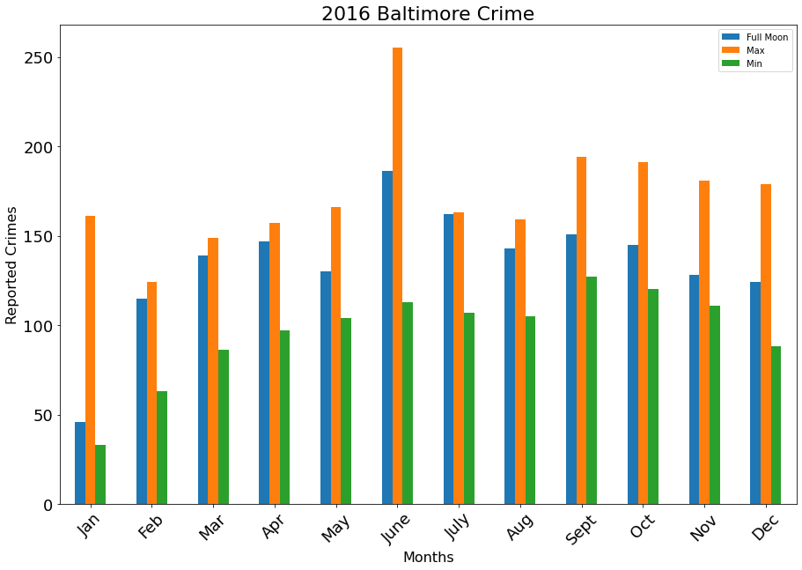

* Month with the day of most crime

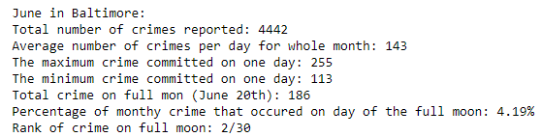

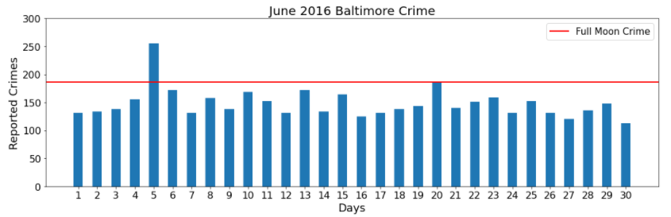

* Month with the day of least crime:

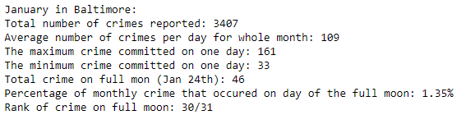

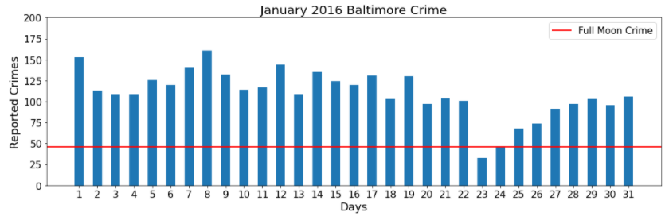

* + Philadelphia:
    - The graph shows the maximum crime, minimum crime and full moon crime data onto a multi-bar graph.

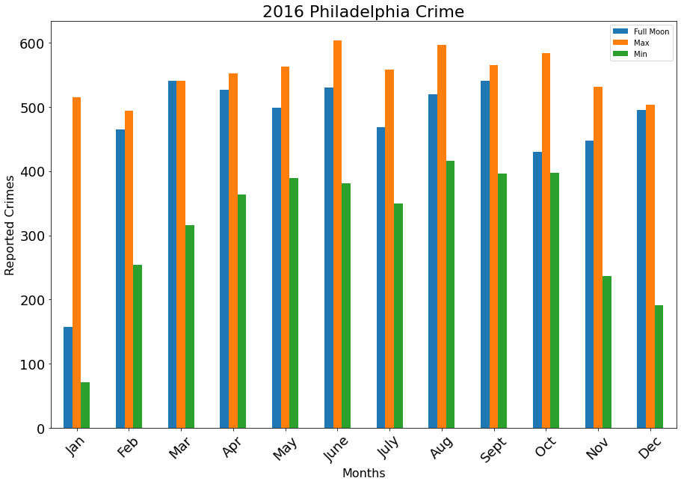

* Month with the day of most crime:

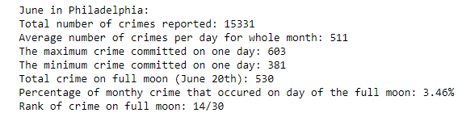

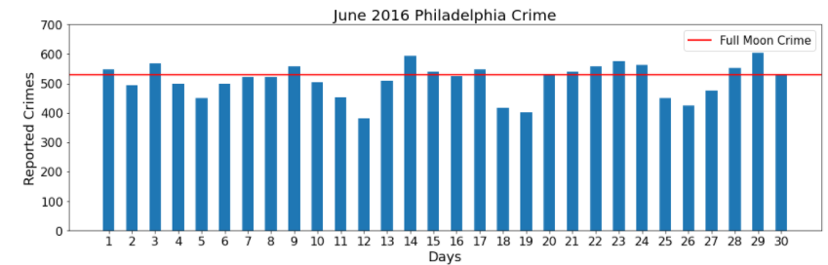

* Month with the day of least crime:

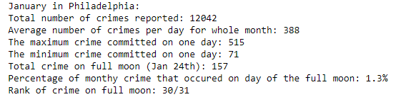

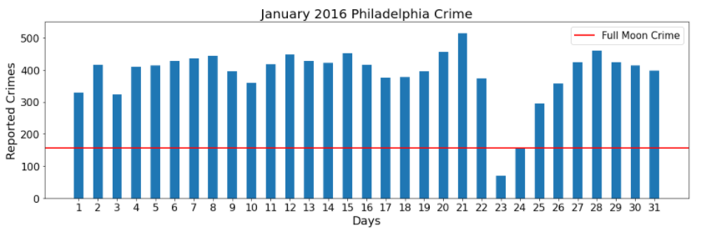

* **Findings**
  + Given our analysis, we reject our alternate hypothesis. Crime rates were not impacted by a full moon.
  + Out of the 36 months we looked at there was only one month where the most crime occurred on the full moon. (March in Philadelphia)
  + If we had more time, we would have considered the following questions:
    - Is a particular type of crime more common on nights with a full moon?
    - Does one cycle of the moon impact crime rate more than others?
    - Does another astrological phenomenon such as a lunar or solar eclipse affect crime rate?